**Picviz Inspector Quick Start**

**Credentials**

Picviz Inspector

Login : picviz / Password : picviz

Administration

Login: root / Password : root

**Monitors installation**

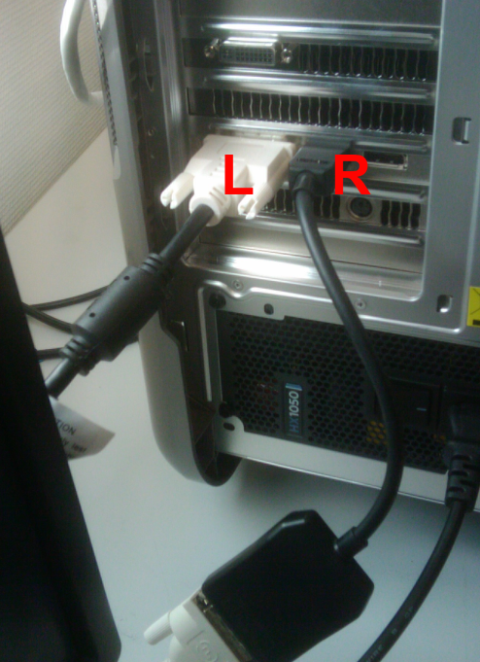

Install the Left monitor like what you see on the picture on the ‘L’ letter.

Install the Left monitor like what you see on the picture on the ‘R’ letter using an adapter.

**Get Started!**

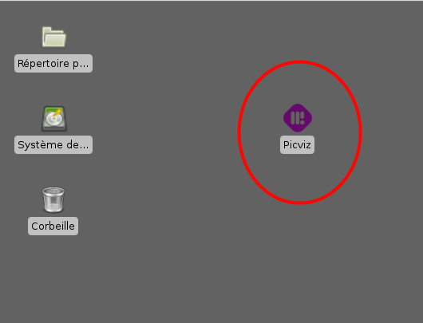

Double-click on the Picviz icon to start Picviz Inspector

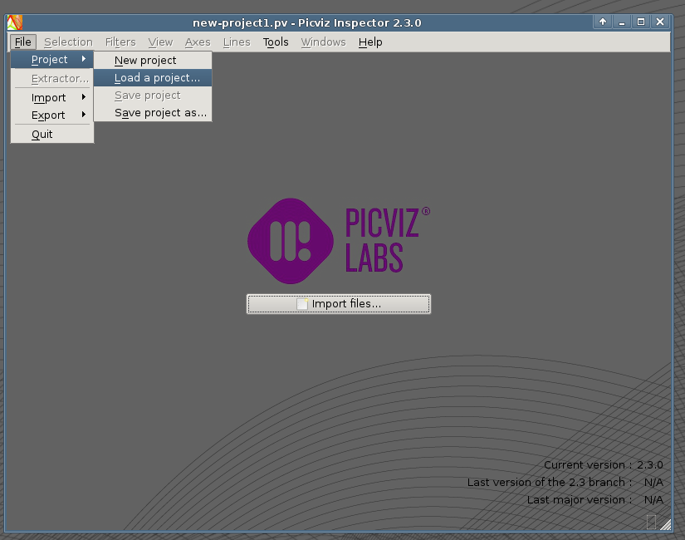

Open a sample project to get started, we will take ssh authentication and attacks logs.

Click in the menu in File/Project/Load a project…

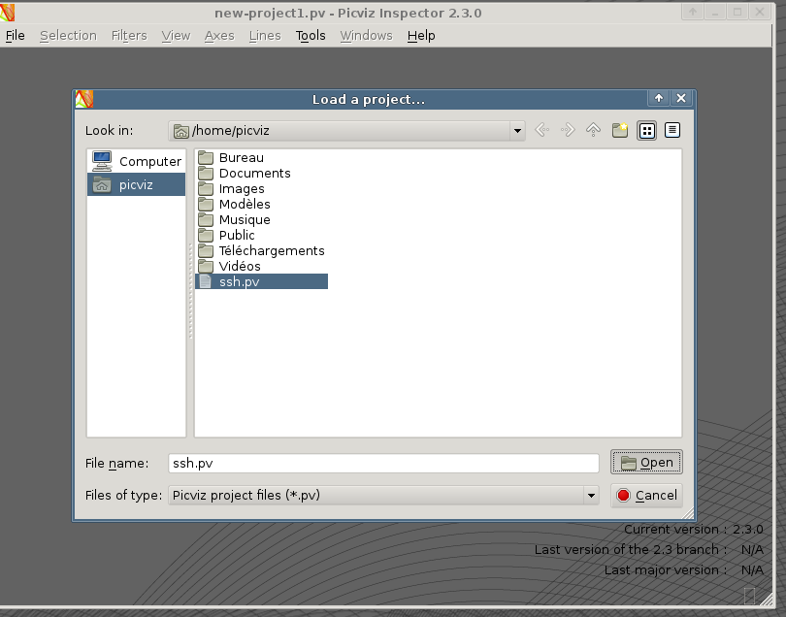

Open ssh.pv which is the Picviz Project for ssh authentication.

You can now use the two displays and start your investigation!

